FEDERATION OF BOLDMERE SCHOOLS
BUSY BODIES BEFORE AND AFTER SCHOOL CLUB
CHARGING POLICY 2017
Registration fees
A registration form must be completed for all children who will be attending the club on a regular basis. A registration fee will be paid annually for each child. Families with three or more children attending will be entitled to a reduction of 50% for their third child.
Morning session
The standard morning session is 8.00 am to 9.00 am. Children may be admitted at 7.45 am.
On arrival parents/carers must register their child/ren as present.
Afternoon session
The afternoon session is from 3.30 pm to 6.00 pm. The minimum payment is for one hour, and then half hourly payments thereafter.
Children who are attending other after school activities and who will be returning to Busy Bodies later, must pay for the whole session as this time cannot be allocated to other families.
All parents must sign their children out at the end of the day stating the accurate time of collection. If this is later than was originally booked, the additional payment must be made at that point or an invoice will be issued.
Monthly fees
Fees are payable one month in advance. All parents must complete a booking form for each month, and the form and appropriate payments are to be received before the last Friday in the preceding month.
We will be unable to refund or credit to another month fees once your monthly booking form is received, as staffing is based on the numbers attending each session and must be accurate to ensure the safety and well-being of our children.
In exceptional circumstances e.g. family bereavement, child’s illness causing absence of one week or more, it may be possible to credit some sessions across to the following month but parents would need to speak to the Manager about this.
Late fees
Please note that if a parent/carer has not paid in advance their monthly fees, (we will only allow a few days’ grace being the proceeding Wednesday) care will not be provided until all said bookings and fees are paid.
College/Bursary payments
Parents must produce proof of such payments and sign an agreement with the club stating that fees will be paid regularly or care will be suspended. If staff become aware of any parent giving false information when claiming childcare costs, they have the right to inform the authorities.
Late collection
Parents who are late collecting their children will be charged. On the occasion of staff having no contact from parent carers after 6.30 p.m. and staff being unable to contact parents/carers from the list provided, we have responsibility to contact Children’s Information and Advice Service (Early Years Duty Line) who will ensure the safety and welfare of your children.
Emergency cover
For families who are not registered with the club, emergency cover can be provided if numbers attending allow. Costs for this service reflect the fact that no registration fee has been paid. A form must be completed detailing emergency contact numbers and any medical or allergies your child may have.

I ……………………………………parent/carer understand
and agree to abide with this charging policy. Dated………………….
Club charges 2017
Registration fees
£25.00 per child.
Session fees
Morning session
7.45 a.m. to 9.00 a.m £5.80
8.00 a.m to 9.00 a.m £4.75
Afternoon session
3.30 p.m to 4.30 p.m £4.75
3.30 p.m to 5.00 p.m £7.12
3.30 p.m to 5.30 p.m £9.50
3.30 p.m to 6.00 p.m £11.87

Session fees – unregistered children
Morning charge
7.45 a.m to 9.00 a.m £8.44
Evening charge
3.15 p.m to 5.00 p.m £8.44
3.15 p.m to 6.00 p.m £16.88
Late Charges
  - p.m £ 10.00
6.30 p.m £20.00
Payments can be made by childcare voucher schemes, directly into the bank, cash or cheque, see further information on your monthly booking form
Should any parent/carer have difficulties in paying fees for any reason or would like to enquire further about fees charged then please address all correspondence to The Head Teacher, Boldmere Junior School Governing Body who will deal with each case in the strictest confidence.

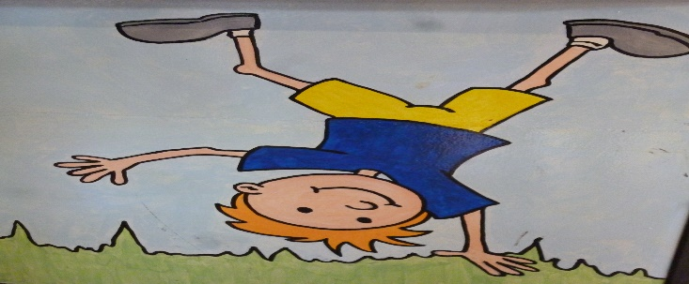

Parents kindly complete the following information attaching a small photo of your child

Medical Information

Name of child…………………………………………

Class…………………

Medical Condition and details………………

………………………………………………………………..

Medication Requirements…………… photo of your child would be very helpful

………………………………………………………

Medication is stored …………………………………….
Care plan to be attached

……………………………………………………………………………………………….

Food Allergies/I am not allowed
To eat a specific food

Name…………………………………………………………

Class…………………………………….

What food should I not eat……………………….

…………………………………………………………………..

I have medication for this condition called

……………………………………………………………………..

Medication is stored in……………………photo of your child would be very helpful
Care plan to be attached

Parental Responsibility

The Early Years Foundation Stage Framework Statutory Requirement ‘Safeguarding and promoting children’s welfare’ states that childcare providers must obtain ‘information about who has legal contact with the child and who has parental responsibility’.
( For guidance on what parental responsibility means visit
http://www.direct.gov.uk/en/Parents/ParentsRights/DG_4002954 and see attached page.)

I therefore require all parents/carers to complete the form below, prior to their child being admitted into my care. If there are any subsequent changes to these details please let me know immediately

Name of Child

Date of Birth

Parent/Carer 1
Name
Relationship
Legal contact yes/no
Parental responsibility yes/no

Parent/Carer 2
Name
Relationship
Legal contact yes/no
Parental responsibility yes/no

Parent/Carer 3
Name
Relationship
Legal contact yes/no
Parental responsibility yes/no

Date form completed

Information taken from :

http://www.direct.gov.uk/en/Parents/ParentsRights/DG_4002954

Who has parental responsibility?
In England and Wales, if the parents of a child are married to each other at the time of the birth, or if they have jointly adopted a child, then they both have parental responsibility. This is not automatically the case for unmarried parents.
According to current law, a mother always has parental responsibility for her child. A father, however, has this responsibility only if he is married to the mother when the child is born or has acquired legal responsibility for his child through one of these three routes:
- (after 1 December 2003) by jointly registering the birth of the child with the mother
- by a parental responsibility agreement with the mother
- by a parental responsibility order, made by a court
Living with the mother, even for a long time, does not give a father parental responsibility and if the parents are not married, parental responsibility does not always pass to the natural father if the mother dies.
All parents (including adoptive parents) have a legal duty to financially support their child, whether they have parental responsibility or not.

What is parental responsibility?
While the law does not define in detail what parental responsibility is, the following list sets out the key roles:
- providing a home for the child
- having contact with and living with the child
- protecting and maintaining the child
- disciplining the child
- choosing and providing for the child's education
- determining the religion of the child
- agreeing to the child's medical treatment
- naming the child and agreeing to any change of the child's name
- accompanying the child outside the UK and agreeing to the child's emigration, should the issue arise
- being responsible for the child's property
- appointing a guardian for the child, if necessary
- allowing confidential information about the child to be disclosed

Applying to the courts for parental responsibility
A father can apply to the court to gain parental responsibility. In considering an application from a father, the court will take the following into account:
- the degree of commitment shown by the father to his child
- the degree of attachment between father and child
- the father's reasons for applying for the order
The court will then decide to accept or reject the application based on what it believes is in the child's best interest.

