Speed Bounce
Children work individually to complete as many speed bounces as possible in the time. Place an object on the floor and jump over this as many times as you can in a set time! (We recommend 30 seconds but this can be shortened or lengthened to suit your child!)
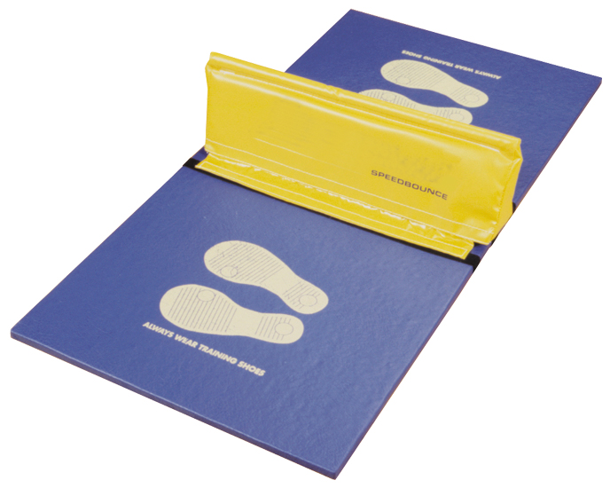

Step Ups
Children complete as many ‘Step Ups’ as possible in an time. To count, the person participating must place one foot on a bench (or similar object) then step their second foot up before removing their first foot and following with their second foot (right foot up, left foot up, right foot down, left foot down = 1).
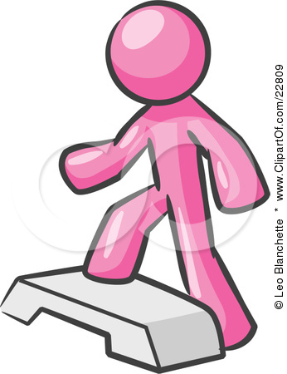

Skipping
Children complete as many skips as possible in an allocated time.

Star Jumps
Children work individually to complete as many ‘Star Jumps’ as possible in the time.
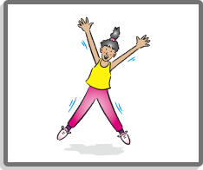

Sit Ups
Children work individually to complete as many ‘Sit Ups’ as possible in the time. Ask a family member to hold your legs/feet to help you.
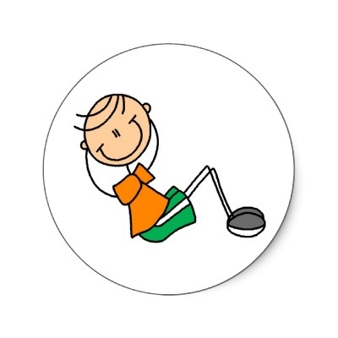

Shuttle Runs
Children run from the starting point at one cone (or other similar marker) in a clockwise (or anticlockwise) direction (please agree this before they start) to the other cone (or object). Count how many you can do in an allocated time.
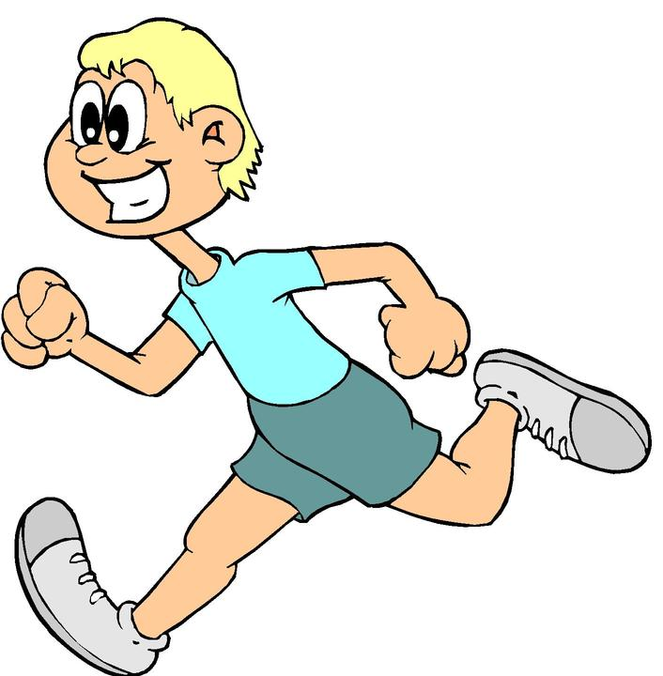

Spotty Dog
Children work individually to complete as many Spotty Dogs as possible in the time. Children start with their right foot and left arm forward – as if about to start a running race. Alternate your legs forwards and backwards. This is running on the spot essentially, but great for co-ordination!
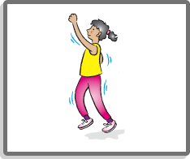

Squats
With backs against the wall, slide down so that the legs are bent and the knees are bent at 90º.
Adaptation: squat without the wall, make sure there is a straight line from ankle to knee and that bottom goes out behind the feet, back straight.
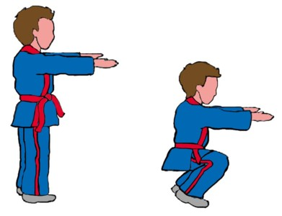
Beanbag Hold
Keep your arms parallel to the floor and hold a beanbag (or other similar item) up for the whole time.
Adaption: This exercise can be made more difficult by asking the children to slowly rotate their arms!

Ball head, shoulder, knees and toes.
Children start with ball held above their head, they then must bring it down to shoulder height, then down to knees and finally to toes before reversing the process. Children need to be shown the correct way of bending down.
Adaption – Use a tennis ball rather than a football
